Project Design Phase-II
Technology Stack (Architecture & Stack)

Date | 29 October 2025
Team ID | NM2025TMID07034
Project Name | Optimizing User, Group, and Role Management with Access Control and Workflows
Maximum Marks | 4 Marks

Technical Architecture
The project architecture focuses on creating a secure, automated, and scalable environment for managing users, groups, and roles through access control and workflow automation.
It combines frontend interfaces, workflow engines, backend logic, and access control layers to ensure secure and efficient role management.
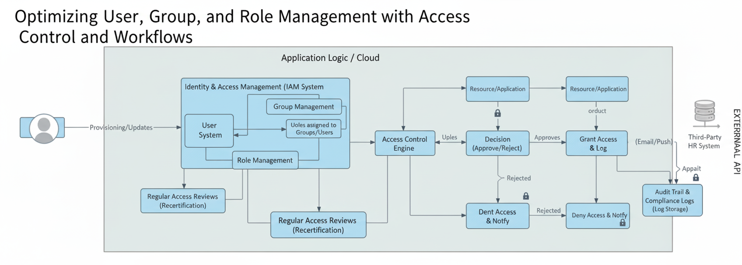

Table 1: Components & Technologies
S.No | Component Description | Technology Used
1. | User Interface (UI) – Admin and users interact through a responsive dashboard for user, group, and role operations. | React.js / HTML / CSS / JavaScript
2. | Application Logic Layer – 1: Handles user creation, validation, and group-role assignment. | Node.js / Express.js
3. | Application Logic Layer – 2: Implements dependency validation between user, group, and role relationships. | Server-side scripting (JavaScript / Node.js)
4. | Workflow Engine: Automates approval processes for user access requests. | ServiceNow Flow Designer / Node Workflow Library
5. | Access Control Engine (RBAC): Enforces access restrictions and role-based permissions dynamically. | Role-Based Access Control (RBAC) Logic / Middleware
6. | Database Layer: Stores user profiles, group details, roles, and access history. | MySQL / PostgreSQL
7. | Cloud Infrastructure: Provides scalability, hosting, and backup support for the application. | AWS / Azure Cloud Services
8. | API Gateway: Facilitates communication between frontend, backend, and external integrations. | RESTful APIs
9. | Audit and Logging Service: Tracks workflow and access control events for monitoring and compliance. | MongoDB / Elasticsearch / ServiceNow Logs
10. | Notification System: Sends alerts and status updates after workflow approval or access changes. | NodeMailer / Firebase Cloud Messaging (FCM)
11. | External Integration (Optional): Connects with third-party HRMS or LDAP for user verification. | LDAP Integration / REST API
12. | Infrastructure (Deployment): Deployed on scalable cloud environments for continuous availability. | AWS EC2 / Azure App Service

Table 2: Application Characteristics
S.No | Characteristic | Description | Technology / Implementation
1. | Open-Source Frameworks | Uses open-source frameworks for scalability and ease of customization. | Node.js, React.js
2. | Security Implementations | Incorporates Role-Based Access Control (RBAC), secure session handling, and encrypted communications. | JWT Authentication, ACLs, HTTPS
3. | Scalable Architecture | Built with a modular and microservice-ready structure to handle large-scale enterprise workloads. | Node.js, AWS Auto Scaling
4. | Availability | High availability ensured through load balancing and failover redundancy. | AWS Elastic Load Balancer / Azure Cloud Load Balancing
5. | Performance | Optimized through asynchronous workflows, caching, and efficient database indexing. | Redis Cache / Indexed SQL Queries
6. | Auditability | Each user action, role change, or workflow approval is logged for compliance and traceability. | MongoDB Logs / CloudWatch
7. | Maintainability | Designed with modular components for easy updates and debugging. | Docker Containers / CI-CD Pipelines
8. | Interoperability | Supports integration with identity management systems and third-party applications. | REST APIs / LDAP / OAuth 2.0

